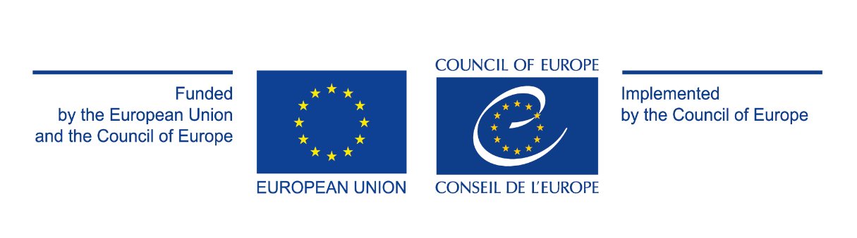
Human Resources Management in Local Self-Governments – Phase 2

Purchase of consultancy services for supporting NAPA in development and implementation of up to 60 selected trainings (webinars) for LSG employees within Sectoral Continual Professional Development Programme (SCPDP)

[Contract N° 4708/2021/67a]

Question and Answers
29 November 2021

Question 1
In the case of a consortium of natural persons, do we have to submit only one Act of Engagement (with information about natural persons), or do we have to submit separate applications?

Answer
Please refer to Article 10 of Legal Conditions of the Act of Engagement.

